Open Economy - The Global Manager's Dilemma
Nima Fazeli

Objective
Analyze the impact of exchange rate fluctuations on a firm with international operations.

Setup: Your Company & The Shock
You are managers at a U.S.-based company, "Global Gadgets Inc."
- Revenues: 50% from sales in Europe, priced in Euros (€).
- Costs: Key components are sourced from Japan, priced in Yen (¥).
- The Shock: The U.S. Federal Reserve has been raising interest rates more aggressively than the European Central Bank (ECB) and the Bank of Japan (BoJ).
Let's see what that has done to the dollar.
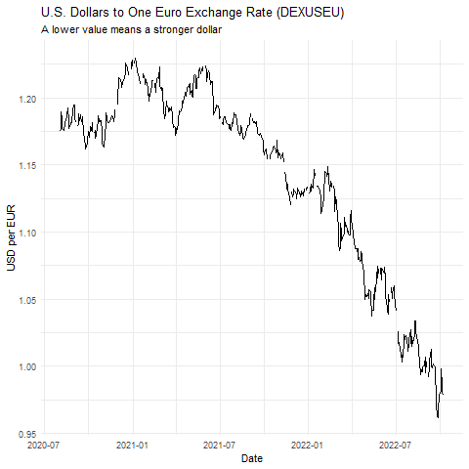

Group Task: Assess the Damage
As the graph shows, the dollar has strengthened (fewer USD needed to buy one EUR). Split into two teams:
- Team Revenue (Sales in Europe): Your revenues are in Euros. When you convert them back to USD for your financial statements, what is the impact of the stronger dollar? Is this good or bad for reported profits? What is one action you could recommend?
- Team Costs (Sourcing from Japan): Your costs are in Yen. (Assume for this exercise the Yen has also weakened against the strong dollar). When you pay your Japanese suppliers, what is the impact? Is this good or bad for your cost of goods sold (COGS)? What is one action you could recommend?

Debrief
- Which part of the business is hurt by a strong dollar?
- Which part is helped?
- This highlights FX exposure as a critical two-sided risk for global firms. What are some ways to manage it?

