Intel's Big Bet: The CHIPS Act and Global Foundry Strategy
Nima Fazeli

Objective
- To analyze a major corporate investment decision driven by industrial policy and geopolitics, not just market fundamentals.
- To evaluate the financial and strategic trade-offs of on-shoring a critical, capital-intensive supply chain.
- To apply business cycle management concepts to a long-term, highly cyclical industry.

The Situation: 2022
You are on the strategic planning team for Intel CEO Pat Gelsinger. The company is at a historic crossroads.
- Competitive Crisis: Intel has lost its long-held manufacturing leadership to Taiwan's TSMC and South Korea's Samsung. Its most valuable customers, like Apple, have abandoned Intel processors for their own designs, manufactured by TSMC.
- The COVID Shock: The pandemic revealed the profound fragility of the hyper-concentrated global semiconductor supply chain. A global chip shortage brought auto factories and electronics production to a halt, demonstrating that semiconductor manufacturing is critical national infrastructure.
- Geopolitical Tensions: The escalating rivalry between the U.S. and China over technology leadership, coupled with the risk of a conflict over Taiwan (home to TSMC), has made reliance on Asian manufacturing a massive strategic vulnerability for the entire Western world.
In response, the U.S. government passed the CHIPS and Science Act, a landmark piece of industrial policy allocating $52 billion in subsidies to incentivize companies to build semiconductor fabrication plants ("fabs") on U.S. soil.

The Managerial Dilemma: A $100 Billion Gamble
CEO Pat Gelsinger has announced a bold and incredibly expensive strategy: Intel will invest over $100 billion to build new fabs in Arizona and Ohio and become a "foundry" service, manufacturing chips for other companies (like TSMC does). This is a bet-the-company move.
The strategy announced by the CEO is called IDM 2.0 and is public in a press release as of March 2021.
The question for your team is: Is this visionary strategy or a catastrophic miscalculation?
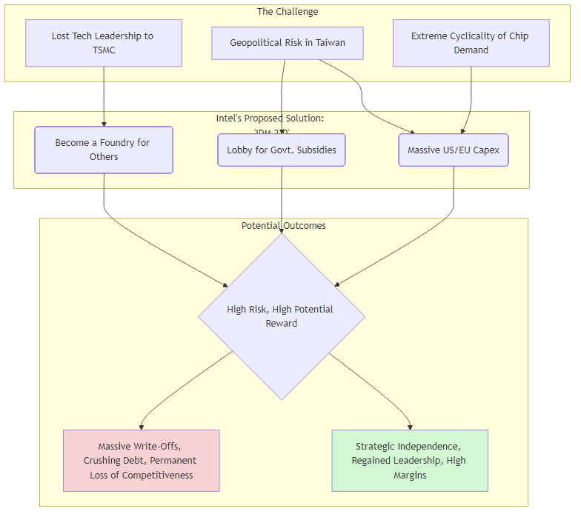

Group Task: Memo to the CEO (30 min)
Your team must prepare a one-page memo for Pat Gelsinger evaluating this strategy. Address the following:
- The Financial Impact: What does this strategy do to Intel's financials in the short-term (next 3-5 years)? Discuss the impact on:
  - Free Cash Flow (FCF): What will happen to CapEx? What does this mean for FCF?
  - The Balance Sheet: How will Intel likely fund this? What does that do to its debt levels and financial risk?
- The Cyclical Risk: The semiconductor industry is famously cyclical. We are in 2022, and the yield curve is inverting while the PMI is falling, signaling a potential recession. How does the business cycle complicate this massive investment plan? What happens if a deep recession crushes chip demand right as Intel's new, expensive fabs come online?
- Final Recommendation (Go / No-Go / Go-Slow): Should Intel proceed with this $100B bet?
  - Justify your answer. Frame it as a trade-off. Is the long-term geopolitical and strategic benefit worth the enormous short-term financial risk and cyclical exposure? What is the "cost of failure" vs. the "cost of inaction"?

